**Project Development Phase Model Performance Test**

|  |  |
| --- | --- |
| Date | 10 November 2022 |
| Team ID | PNT2022TMID52712 |
| Project Name | Smart Lender - Applicant Credibility Prediction  for Loan Approval |
| Maximum Marks | 10 Marks |

# Model Performance Testing:

Project team shall fill the following information in model performance testing template.

|  |  |  |  |
| --- | --- | --- | --- |
| **S.No.** | **Parameter** | **Values** | |
| 1. | Metrics | **Classification Model: Decision Tree**  Accuracy Score - 84%  **Classification Report**  precision recall f1-score 0 0.83 0.84 0.83  1 0.85 0.85 0.85 | support 105  118 |
| 2. |  | **Classification Model: Random Forest**  Accuracy Score - 84%  **Classification Report**  precision recall f1-score 0 0.89 0.81 0.85  1 0.84 0.91 0.87 | support 105  118 |
| 3. |  | **Classification Model: KNN**  Accuracy Score - 78%  **Classification Report**  precision recall f1-score 0 0.82 0.70 0.76  1 0.77 0.86 0.81 | support 105  118 |
| 4. |  | **Classification Model: XGBoost**  Accuracy Score - 85%  **Classification Report**  precision recall f1-score 0 0.90 0.77 0.83  1 0.82 0.92 0.87 | support 105  118 |

**DECISION TREE CLASSIFIER**

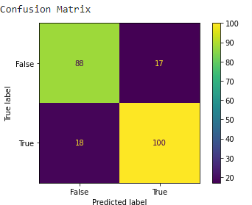

# RANDOM FOREST CLASSIFIER

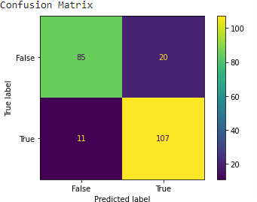

**KNN**

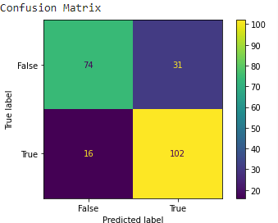

# XG BOOST

